TAX SHELTER ACCOUNT
SALARY REDUCTION AUTHORIZATION

To authorize my employer to make contributions into my 403(b) plan
with Oldham Resource Group, Inc.

New Participant Continue Same Deduction Increase Decrease

Plan Name ___________________ Redirect Contributions From: _________________

Lump Sum Deposit To: _________________

MAXIMUM LIMIT: ___________________ YEAR: ________________

Deduct from my salary:

Beginning on this date ____/____/____ and for subsequent pay periods deduct

from my salary $ ________________.

This reflects $____________ X ______ number of pays (w/deductions) / months

totaling $ _________________ per year.

This agreement supersedes and terminates all previous salary reduction agreements. I understand I may stop my deductions at any time.

The maximum amount of salary reduction contributions may not exceed the limits of IRC 402(g), 415(c) and 414(v).

_________________________________________________ __________________________________
Employee Signature Social Security Number

North Stonington Public Schools
________________________________________________ __________________________________
Name of Employer Dated
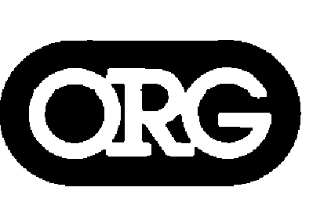OLDHAM RESOURCE GROUP, INC.
70 New Canaan Avenue, Norwalk, CT 06850
(203) 847-5300 Toll Free (800) 626-6106 FAX (203) 845-0390

Oldham Resource Group, Inc. offers this and other forms only as guides to our clients, Responsibility for modifying and guiding a client’s actions, with respect to legal matters and tax matters, is placed where it properly belongs – with his/her counsel.
Securities and Advisory services offered through GWN Securities Inc. A Registered Investment Advisor. Member FINRA/SIPC. 11440 N. Jog Road, Palm Beach Gardens, FL 33418. 561-472-2700. GWN Securities, INC. and Oldham Resource Group are not affiliated companies.

